# Report

**Feedback Loop Stability Analysis with MATLAB**

Kesh Pratap Singh  
 210107042

Chemical Engineering

# PROBLEM STATEMENT

You are given a transfer function of a feedback loop

Do the following operation using MATLAB:-

1. Plot the step response of this transfer function.
2. Plot the bode diagram and check stability.
3. Plot the root locus diagram and locate the poles and zeros.

## Stability of a Feedback Loop

Stability typically means that all internal signals stay within bounded limits. This is a standard requirement in control systems to prevent loss of control and potential damage to equipment. In linear feedback systems, stability can be evaluated by examining the poles of the closed-loop transfer function.

Consider for example the SISO feedback loop:

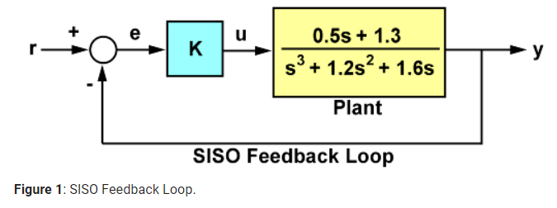

For a unit loop gain k, we can compute the closed-loop transfer function T using

Let’s draw the closed loop response for k=1;



The corresponding closed-loop step response exhibits about 20% overshoot and some oscillation.

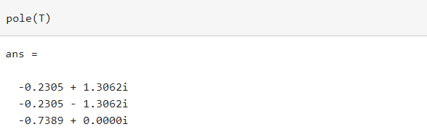2)for finding roots

The feedback loop for k=1 is stable since all poles have negative real parts.

Checking the closed-loop poles gives us a binary assessment of stability. In practice, it is more useful to know how robust (or fragile) stability is. One indication of robustness is how much the loop gain can change before stability is lost. You can use the root locus plot to estimate the range of k values for which the loop is stable:

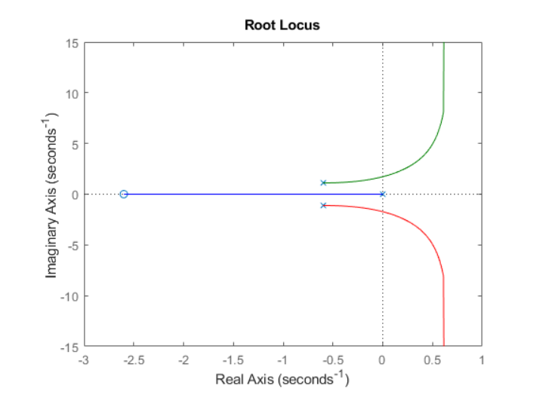

Clicking on the point where the locus intersects the y axis reveals that this feedback loop is stable for

$$ 0 < k < 2.7 $$

**Gain and Phase Margins**

Changes in the loop gain are only one aspect of robust stability. In general, imperfect plant modelling means that both gain and phase are not known exactly. Because modelling errors are most damaging near the gain crossover frequency (frequency where open-loop gain is 0dB), it also matters how much phase variation can be tolerated at this frequency.

The phase margin measures how much phase variation is needed at the gain crossover frequency to lose stability. Similarly, the gain margin measures what relative gain variation is needed at the gain crossover frequency to lose stability. Together, these two numbers give an estimate of the "safety margin" for closed-loop stability. The smaller the stability margins, the more fragile stability is.

We can display the gain and phase margins on a Bode plot as follows. First create the plot:

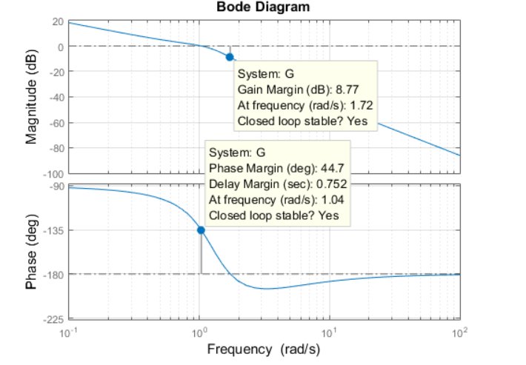

This indicates a gain margin of about 9 dB and a phase margin of about 45 degrees. The corresponding closed-loop step response exhibits about 20% overshoot and some oscillations.

If we increase the gain to k=2, the stability margins are reduced to

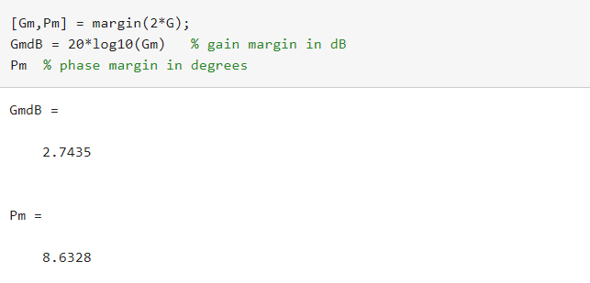

and the closed-loop response has poorly damped oscillations, a sign of near instability.

**Systems with Multiple Gain or Phase Crossings**

Some systems have multiple gain crossover or phase crossover frequencies, which leads to multiple gain or phase margin values. For example, consider the feedback loop

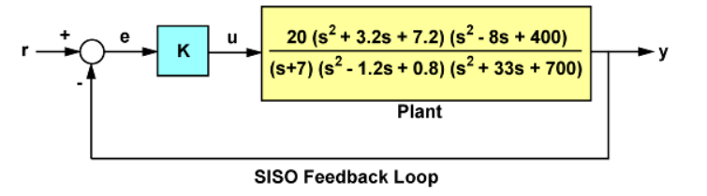

To assess how robustly stable this loop is, plot its Bode response:

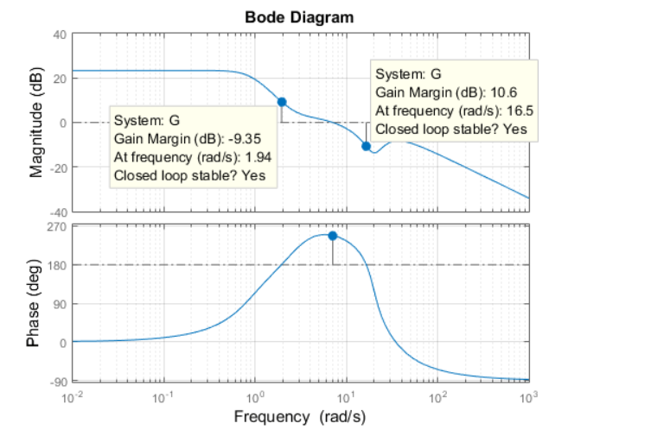

Note that there are two 180 deg phase crossings with corresponding gain margins of -9.35dB and +10.6dB. Negative gain margins indicate that stability is lost by decreasing the gain, while positive gain margins indicate that stability is lost by increasing the gain. This is confirmed by plotting the closed-loop step response for a plus/minus 6dB gain variation about k=1:

**Let’s draw step response for different values of K**

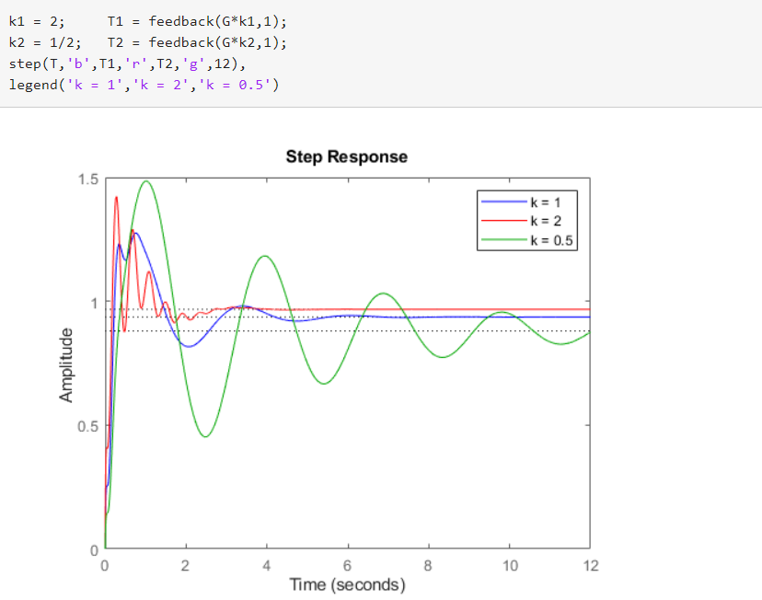

The plot shows increased oscillations for both smaller and larger gain values.

## REFERENCES:

TEXTBOOK:- Chemical Process Control: An Introduction to Theory and Practice

<https://www.mathworks.com/matlabcentral/fileexchange/116500-process-dynamics-and-control-course>